Do not capitalize your short-paper title

A. B. Lastname^{1*}, C. Lastname^{2,3}, …., and F. Lastname³

¹ Department of Example Science, Example University, City, Country

² Example Labs, City, Country

³ Company, City, Country

* Corresponding author, email: author@example.edu
Abstract: Place a brief summary of your work here. Do not use more than 100 words. 3D printing is of outstanding importance in medical engineering and has been growing continuously in recent years. From prostheses and soft implants to matrices for tissue engineering, additive manufacturing has decisive advantages for medicine. The scientific conference AMMM 2020 brings together engineers, scientists and technicians with physicians and entrepreneurs to discuss the latest achievements in 3D printing development for medicine.
© 2020 Corresponding Author; licensee Infinite Science Publishing
This is an Open Access article distributed under the terms of the Creative Commons Attribution License (http://creativecommons.org/licenses/by/4.0), which permits unrestricted use, distribution, and reproduction in any medium, provided the original work is properly cited.

I. Introduction
Two section headers should not follow each other directly without textual content.

I.I. Subsection
Your paper should have not more than two pages. The template is used to format your paper and style the text. All margins, column widths, line spaces, and text fonts are prescribed; please do not alter them. Do not squeeze more text into the limited number of pages. Use only the formats defined for this document.
Number equations consecutively with equation numbers in parentheses flush with the right margin, as in (1). Use parentheses to avoid ambiguities in denominators. Punctuate equations when they are part of a sentence, as in
$\frac{d}{dx}\left(\int_{0}^{x}{f\left(u\right)du} \right)=f\left(x\right) .$ (1)
Please note that the book of abstracts will be black and white. Make sure figures are still legible. The digital versions of your paper to be published in Transactions on Additive Manufacturing Meets Medicine (Trans. AMMM, Volume 2, Number 1, 2020) will be in full color. Fig. 1 is an example for a black and white figure.
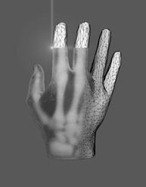
  - Figure 1: It is good practice to explain the significance of the figure in the caption. Each figure should be able to be standing alone. You may use full color images. Please have in mind that images are in b/w in the printed book of abstracts.
Do not put borders around your figures. Each figure/table should be mentioned in the text.
Use the abbreviation “Fig.” throughout the text of your abstract, even at the beginning of a sentence.
Figure axis labels are often a source of confusion. Use words rather than symbols. As an example, write the quantity “Energy” or “Energy, E” not just “E”. Separate units with a slash, e.g. “Energy / J” or “Energy in J”. Do not label axes only with units.

I.II. Second subsection, if necessary
To provide consistent reproducibility, please include axes and tick marks on all four sides of your graphs and avoid the use of grid lines (note that grid lines tend to clutter a graph if dark or reproduce poorly if light). Please also include an explanatory legend within your graphs when two or more curves or sets of data are included. Avoid explaining the different symbols and curves in the figure caption alone - using a legend results in a much more easily understood figure. Do not abbreviate “Table”. Tables are numbered with Arabic numerals, as can be seen in Table 1.
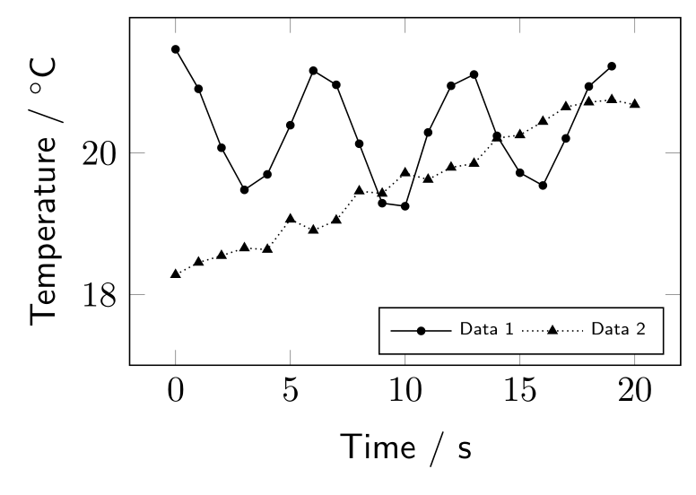
  - Figure 2: Format your data graphs as described in the text above.

II. Material and methods
Define abbreviations and acronyms the first time they are used in the text, even after they have been defined in the abstract. Abbreviations such as IEEE, SI, MKS, CGS, sc, dc, and rms do not have to be defined. Do not use abbreviations in the title or heads unless they are unavoidable.
  - Table 1: Font size and format.
Format Style | Font Size  and Type | Element
Title | 24, Bold, Calibri | Title
Author List | 12, Bold, Calibri | Authors
Affiliations | 12, Italic, Calibri | Affiliation
Corr. Author’s E-Mail Address | 12, Italic, Calibri | Affiliation
- Abstract | 9, Italic, Times New Roman | Abstract
Section Title | 14, Bold, Calibri | Section Title
Subsection Title | 12, Bold, Calibri | Subsection Title
Text | 10, Times New Roman | Standard
- Figure Caption | 9, Italic, Times New Roman | Caption
- Table Caption | 9, Italic, Times New Roman | Caption
Acknowledgment Title | 10, Bold, Calibri, Small Caps | Acknowledg-ments
Acknowledgment Textblock | 8, Times New Roman | Acknowledg-ment Textblock
Author’s Statement Title | 10, Bold, Calibri, Small Caps | Acknowledg-ments
Author’s Statement  Textblock | 8, Times New Roman | Acknowledg-ment Textblock
Reference Title | 10, Bold, Calibri, Small Caps | Acknowledg-ments
Reference Textblock | 8, Times New Roman | Reference Style

III. Results and discussion
Some common mistakes:
- The word “data” is plural, not singular.
- The subscript for the permeability of vacuum μ₀, and other common scientific constants, is zero with subscript formatting, not a lowercase letter “o”.
- In American English, commas, semi-/colons, periods, question and exclamation marks are located within quotation marks only when a complete thought or name is cited, such as a title or full quotation. When quotation marks are used, instead of a bold or italic typeface, to highlight a word or phrase, punctuation should appear outside of the quotation marks. A parenthetical phrase or statement at the end of a sentence is punctuated outside of the closing parenthesis (like this). (A parenthetical sentence is punctuated within the parentheses.)
- A graph within a graph is an “inset”, not an “insert”. The word alternatively is preferred to the word “alternately” (unless you really mean something that alternates).
- Do not use the word “essentially” to mean “approximately” or “effectively”.
- In your paper title, if the words “that uses” can accurately replace the word “using”, capitalize the “u”; if not, keep using lower-cased.
- Be aware of the different meanings of the homophones “affect” and “effect”, “complement” and “compliment”, “discreet” and “discrete”, “principal” and “principle”.
- Do not confuse “imply” and “infer”.
- The prefix “non” is not a word; it should be joined to the word it modifies, usually without a hyphen.
- There is no period after the “et” in the Latin abbreviation “et al.”.
- The abbreviation “i.e.” means “that is”, and the abbreviation “e.g.” means “for example”.

IV. Conclusions
Although a conclusion may review the main points of the paper, do not replicate the abstract as the conclusion. A conclusion might elaborate on the importance of the work or suggest applications and extensions.

Acknowledgments

The preferred spelling of the word “acknowledgment” in America is without an “e” after the “g”. Avoid the stilted expression, “One of us (R. B. G.) thanks . . .” Instead, try “R. B. G. thanks”. Research funding: The author state no funding involved.

Author’s statement (Do not remove this paragraph – please check which statements are applicable)

Conflict of interest: Authors state no conflict of interest. Informed consent: Informed consent has been obtained from all individuals included in this study. Ethical approval: The research related to human use complies with all the relevant national regulations, institutional policies and was performed in accordance with the tenets of the Helsinki Declaration, and has been approved by the authors’ institutional review board or equivalent committee.

References
[1] G. O. Young, Synthetic structure of industrial plastics (Book style with paper title and editor), in Plastics, 2nd ed. vol. 3, J. Peters, Ed. New York, McGraw-Hill, 1964, pp. 15–64.
[2] W.-K. Chen, Linear Networks and Systems (Book style).Belmont, CA: Wadsworth, 1993, pp. 123–135.
[3] J. U. Duncombe, Infrared navigation—Part I: An assessment of feasibility (Periodical style), IEEE Trans. Electron Devices, vol. ED-11, pp. 34–39, Jan. 1959.

